# IICT6203 - Database Programming II

## Worksheet 01 – Views and Sequences

1. Create a view that displays the status name for each username.
2. Query the view and compare your result to the expected output below:

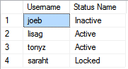

Expected number of rows: 4

1. Create a view that displays the list of orders that are pending payment (filter should be via a subquery). The view should display all attributes of the orders table only. Set the view such that any changes to the data via the view should be limited to the filters of the view.
2. Query the view and compare your result to with the expected output below:

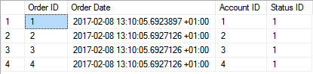

Expected number of rows: 4

1. Create a view that displays all attributes of the product table.
2. Create a sequence for the product id that starts from the 10 and increments by 1. The sequence should not cycle, caches 20 values and has no min and max value.
3. Insert a new product named ‘Samsung Tab 10’ priced at 500. Use the previously created view and sequence.
4. Create a sequence for the order id that starts from 10 and increments by 1. The sequence should not cycle, should have a minimum value of 0 and a maximum value of 1 million. Values for this sequence should not be cached.
5. Use the view and sequence to create a new order by lisag. **Research** how to get the current date, time and offset of the local system and use the function to set the order date. All foreign key values should be obtained via subqueries. Query the orders table and compare it with the below:

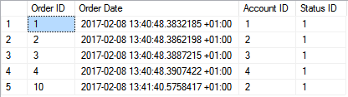

Expected number of rows: 5

1. **Research** on how to retrieve the current value of a sequence and add two Samsung Tab 10 for the new order created in question 9. Query the order items table and compare it with the below:

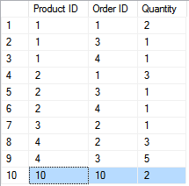

Expected number of rows: 10

1. Use the view created in question 3 to insert a new order placed by lisag. The order should have a ‘Paid in full’ status. Make sure to use subqueries to obtain any values of foreign keys. Observe the outcome and discuss.

***